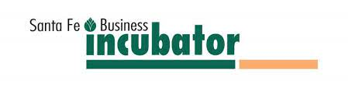
FOR IMMEDIATE RELEASE
Successor Chosen to Lead the Santa Fe Business Incubator
Dana Catron Named New President & CEO
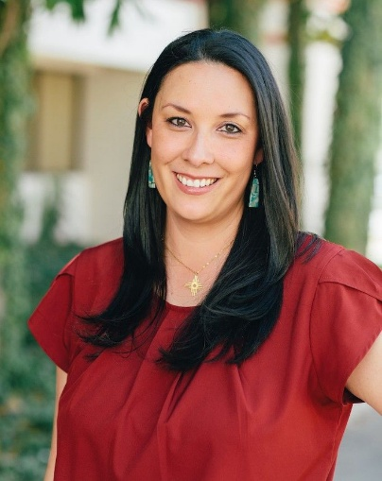
Santa Fe, NM (January 26, 2026)— The Santa Fe Business Incubator (SFBI), northern New Mexico’s first certified incubator, is pleased to announce that after a national search for new leadership, Dana Catron, former Interim Director & CEO of the Arrowhead Center at New Mexico State University, has been named the new President & CEO. Catron will take on the leadership role in February, supported through the transition by Marie Longserre, who is retiring after serving as President & CEO since the Incubator’s inception in 1997.
With 15 years’ experience in various positions at NMSU’s Arrowhead Center, working with entrepreneurs, and a deep knowledge of grants management, Catron is well-equipped to lead the Santa Fe Business Incubator into the future.
Of this new professional opportunity, Catron said, “Marie leaves behind a strong legacy and I am honored to build on the 30-year foundation she established. Drawing on my background in genomics, entrepreneurship, and technology commercialization, my focus will be on expanding SFBI’s impact, supporting Santa Fe’s business community, and strengthening the region’s innovation-driven economy.”
SFBI’s Board Chair, Kent Fuka said, “After a national search and interviewing strong candidates from across the country, Dana stood out as the Board of Director’s top choice. We are delighted that she is from New Mexico, has deep relationships in the entrepreneurial community, and is passionate about advancing the mission of the Santa Fe Business Incubator.”
Outgoing President & CEO Longserre noted how pleased she is to have Catron as her chosen successor and said, “I have known and worked with Dana in business incubation over the years. She has deep knowledge of the startup journey and is dedicated to helping entrepreneurs succeed. The Santa Fe Business Incubator is in strong, capable hands as Dana leads it into the next chapter.”
As SFBI’s first employee, Longserre sheparded the opening of the Incubator in 1997 and the addition that tripled its size in 2001. During her tenure, national and international awards brought attention to the Business Incubator, Santa Fe, and the State of New Mexico.
###
About the Santa Fe Business Incubator: Established in 1997, the Santa Fe Business Incubator helps local entrepreneurs launch and grow successful businesses. These emerging companies create new jobs, increase our tax base, and diversify our economy, enhancing the quality of life for all in our community. The Santa Fe Business Incubator directly serves an average of 22 young firms annually that are headquartered in its 30,000 sq ft facility and assists scores of entrepreneurs and businesses throughout the community and region.
For more information or interviews, please contact:
Heather Hunter, heather@heatherhuntermarketing.com, 210-865-5900

